a) Create a database named CDAC in mongodb shell.

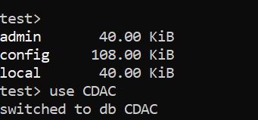

b) Create a collection named Students.

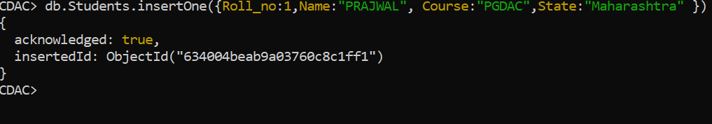

c) Insert some documents to the Students collection with field

Roll_no, Name , Course and State



d) Find all the Students.

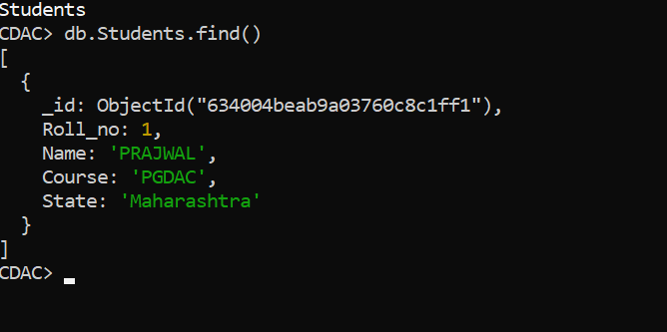

e) Find all the Students with &quot;PGDAC&quot; as their Course.

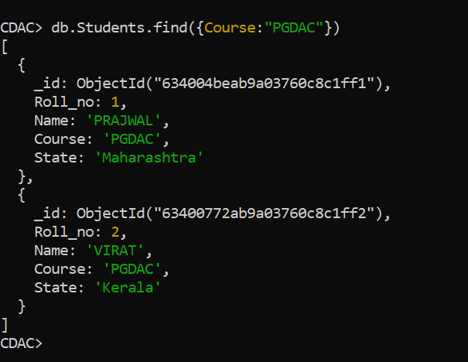

f)Find all the Students with &quot;Kerala&quot; as their State.

